VIETNAM

For years, the name Vietnam for many Westerners conjured up images of the Vietnam War but thankfully, this is at last beginning to change and an increasing number of people are recognising the vast wealth of attractions this beautiful country has to offer as a travel destination. Still not as firmly on the tourist map as Thailand or some of its other neighbours, Vietnam offers a more authentic charm while being relatively easy to travel around. Tourism has developed quite considerably over the past few years, though, making the country an ideal destination for those wanting to venture a little off the beaten track without getting completely lost. The best area to see such scenes is the Mekong Delta, replete with lush green rice paddies under bright blue skies. Even more stunning is the weird and wonderful scenery of Halong Bay, where thousands of rocky islands jut out of the water in haphazard fashion creating a surreal and intensely beautiful vista.
The towns and cities of Vietnam too have a great deal of appeal, combining old French colonial charm with traditional Vietnamese temples and typically Asian streetscapes. The capital, Hanoi, is the first stop on many people's itineraries and has a wonderful air of Oriental mystery with lakes, parks and pagodas dotted around bustling shopping streets. Two of the most famous historical towns are Hue and Hoi An, both with their own unique charms.

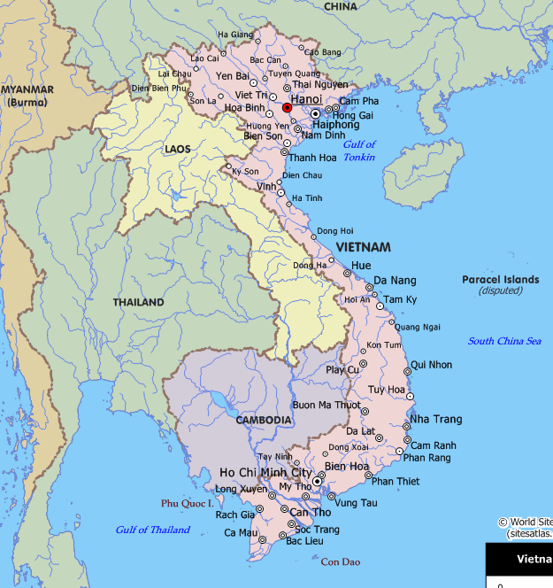

Location
Located in the centre of South east Asia, Vietnam borders China to the North, Laos and Cambodia to the West, the East sea and the Pacific Ocean to the East and the south. Vietnam had thousands of offshore islands, the biggest of which are Hoang sa and Truong Sa islands.
Visas: The visa is to be obtained prior to arrival in the country

Climate
Vietnam lies in the tropical and the subtropical zone, so its climate is affected by two monsoons. In the North, there are four seasons with an average temp. of around 17 degree Celsius in Winter but 34 degree Celsius in summer.
In South, the climate undergoes less variation with an annual average temperature of about 27Degree Celsius in Ho Chi Minh City.

CURRENCY:
Currency: New Dông (VND)
Notes: VND100000, 50000, 20000, 10000, 5000, 2000, 1000, 500, 200 and 100
Coins: Coins are not used
Credit cards: An increasing number of outlets accept Visa and MasterCard. Check with your credit or debit Card Company for details.

US dollars must be new without markings or tears) is used widely. The Euro is also used in Vietnam but less popular than the USD.
Travelers cheques can be exchanged into Vietnamese dong in the banks. Banks are generally open Mon-Fri 08h00-11:30 am and 1:00 to 5:30 pm and Sat 08h00-12h00. Credit cards are becoming popular. ATM is installed in many tourist and economic centers in big cities.
Getting There
Air: The good news is that Vietnam Airlines has a reasonably extensive network of domestic flights, linking all major towns in the country. This cuts down travel time considerably, for example Ho Chi Minh City to Hanoi takes just two hours. The International Airports in Vietnam are: Noi Bai (Hanoi), Tan Son Nhat (Ho Chi Minh City), Da nang (Da Nang City)
There are Domestic Airports in Vietnam Are:
Gia lam in Hanoi, Phu Bai in Hue, Nha Trang, Cam Ranh in Khanh Hoa, Buon Ma Thout in Dak Lak, Lien Khuong in Da lat, Con Son in Ba Ria-Vung Tau, Rach Gia and Phu Quoc in Kein Giang etc.
Aiport Taxes: International flights Adult need to pay some amt appro 14 Usd, free for children under 2yrs.

CLOTHING:
Shorts and sleeveless tops are ok for the beach, but definitely not for a temple visit. In fact the Vietnamese are quite conservative where dress is concerned, and any public exposure of large areas of skin is frowned upon. Shoes also need to be removed before entering many temples - check first.

ELECTRICITY:
The voltage used is 220 volts.

DAILING CODE:
International dialing code: 84 Area codes: Ho chi Minh City: 8, Hanoi: 4, Hue: 54, Nha Trang: 54, Dalat: 63, Danang: 511
City dialing codes are preceded by 0 when dialing within the country. Most post offices offer the facility to make international phone calls. Often you give the operator a deposit and they then dial the number for you and direct you to a booth though direct dialing is becoming more common, for which you can purchase a UniphoneKad telephone card.
CUISINE
Vietnamese cuisine is some of the most enticing in the world, blending South East Asian spices with Chinese style stir-fries and French gastronomy.
There are numerous delicacies in Vietnam, far too many to list here, but these are just some of the most common you are likely to come across. One of the most popular Vietnamese meals is one made up of spring rolls, generally known as cha gio or cha nem. These are filled with meat and/or vegetables, and served with lettuce and a spicy dip. Also very popular are soups called pho (pronounced more like 'fer') that contain noodles and any combination of meat and vegetables. Pho Ga is chicken; Pho Bo is beef. Seafood is available almost everywhere, and one particularly tasty delicacy is chao tom, shrimp fried on a stick of sugar cane. While in Hanoi, try the bun cha, which are small hamburgers grilled and served on noodles and greens with a sweet sauce. In Ho Chi Minh, try Hu Tieu, also known as Saigon soup, made of crab meat, garlic, shrimp and beef stock.

MEDICAL
The tap water is not safe to drink in Vietnam. You should drink bottled water, which is readily available everywhere, even using it to clean your teeth. Avoid drinks with ice in them, as the ice may not be purified. Take care when eating raw vegetables and fruit, as they may either not have been washed or have been washed in tap water. Malaria is present in most of the country so you should consider taking ant-malarial medication. Always use mosquito repellent and wear long sleeves and trousers in the evenings or when near areas of still water where mosquitoes tend to congregate.
Be careful in the sun - always use a high-factor sun cream, wear a hat to avoid heat stroke and drink plenty of water to prevent dehydration. Too much sun is often the prime cause for sickness or diarrhoea in this climate.
There are hospitals in major towns and cities and health care centers in all areas but facilities are limited.
Health insurance is essential and should include cover for emergency repatriation by air.
PERSONAL SAFETY
Though Vietnam is generally a fairly safe country to travel in, petty theft and pick pocketing are rife in Ho Chi Minh City and, to a lesser extent, a problem throughout Vietnam. Common sense precautions should be taken wherever you are to avoid the risk of crime.
Be particularly careful not to leave bags or valuables unattended or to carry them where they can easily be snatched by passing motorcyclists. This is a particular risk when riding in a pedicab, as your belongings are exposed. Pedicab drivers themselves have been known to try to extort money from passengers, so to be on the safe side it's best to only take pedicabs directly associated with your hotel.
Thieves sometimes congregate around international hotels, so be on your guard when entering or leaving your accommodation. Keep your passport and other valuables in your hotel safe where possible and carry a photocopy of your passport with you.

Emergency Numbers:
Police: 113
Ambulance: Tel: 115
Fire: Tel: 114

TIPS:
Tipping is not customary in Vietnam, but a few extra Dong for a meal or service is likely to be greatly appreciated.

LANGUAGE:
Vietnamese is the official language and though French is spoken among older inhabitants as a second language, English is increasingly widely spoken. Chinese, Khmer and Mon-Khmer/Malayo-Polynesian mountain languages are also spoken by pockets of the population.

SHOPPING and MUST BUYS:
The fact that most goods are cheap in Vietnam makes the country a potential shoppers' paradise, but the vendors are no dummies, so in tourist areas you can expect to pay well above the local rates.
If a seller sees you are really interested in a product, the price will often fall dramatically from the first asking price, but try to avoid the kind of penny-pinching antics that give foreigners a reputation for being stingy.
All the major cities stock a variety of typical souvenirs, along with a selection of goods produced by ethnic minorities. If you are heading into the hills, however, you will find better prices for the shoulder bags, jackets and purses fashioned by the local ethnic inhabitants.
Local handicrafts are very popular, such as woven bamboo trays that are painted in bright colours. For something a bit more lavish, check out the lacquerware, which in many cases is inlaid with mother-of-pearl. A figure fashioned of bronze, brass or jade might catch your eye, or perhaps a functioning water puppet painted in glossy colours.
Unusual local instruments make another distinctive choice. Few visitors leave without one of the ubiquitous conical hats, which cost a pittance, and many put them to immediate use to protect themselves from the sun's fierce rays.
The national dress for women, the ao dai, is a practical yet beautiful item of clothing. It consists of baggy trousers and a knee-length dress with a long slit. Normally made of silk the ao Dai cover the entire body but still shows off the figure. Although you might not wear it back home, it makes a lovely souvenir.
Silk in general is readily available and many tailors, especially in Hanoi, will make up silk shirts and other items to order, at very reasonable prices.
One of the most personal of all souvenirs, however, is a painting, either in oil or watercolour, by a local artist. Galleries in Ho Chi Minh City, Hue and Hanoi have a wide stock of paintings available, and unlike in many Western countries, the prices are not sky-high.
Counterfeit merchandise is readily available. The latest CDs and novels can be bought for a few dollars, while brand name clothing rip-offs are similarly cheap. While you might safely bring these items back home with you when you return form Vietnam, the same cannot be said for counterfeit software. Firstly, bootleg software is illegal and may earn you a hefty fine from customs, and secondly, it is likely to contain viruses or copy defects that will play havoc with your system, so beware.
Shops are generally open Mon-Sun 07h30-12h00 and 13h00-16h30.
CITIES:

HO CHI MINH CITY

International departure tax is payable at the airport and is currently USD10. You can pay in American dollars or the equivalent in Dong. There is a domestic departure tax on internal flights. The amount is set in US Dollars but is only payable in Dong. Recently the tax amounted to VND23000, or USD1.50. The amount in Dong is subject to change due to devaluation.

Getting Around
By Train: The country's 2,500 km of railtracks make travelling by train an interesting option.
The main route is up the coast from Ho Chi Minh City to Hanoi, passing Nha Trang, Danang and Hue along the way. It is a marathon journey that takes 30 - 40 hours and it is advisable to have a "soft seat" or bunk for the journey if you want to travel with any degree of comfort.
Three routes fan out from Hanoi; the short route to the coast at Haiphong (for Halong Bay); another directly north to Dong Dang, from where trains continue to Beijing; and the third heads northwest beside the Red River to Lao Cai, from where it continues to Kunming in China.
You need to book a ticket several days in advance since the service is very popular, and while travelling, be on the lookout for pickpockets and hustlers in general.
Many travelers opt for domestic flights in order to save time, but the truth is that train travel can lead to encounters with friendly people that will linger in the memory for years.
By Bus: Traveling on regular buses in Vietnam is an experience most Westerners would prefer not to have. These buses are cramped, slow and break down at every bend. However, the country is gradually waking up to the need for an efficient way of transporting tourists, and comfortable 'open-tour' buses now link the most popular destinations. Note that road quality is almost always poor. Traffic drives on the right (theoretically). The urban speed limit varies from 30-40km per hour and the rural limit from 40-60km per hour, but few drivers actually take any notice of these.
The cheapest - and in many ways - best option of all is renting a bicycle and joining the millions of cyclists causing mayhem at each crossroads.
The following tables provide approximate driving distances from Hanoi and Ho Chi Minh to selected cities. Kilometers on the left of the table, miles on the right.

Hanoi to: | Km | Miles
Danang | 606 | 377
Dien Bien Phu | 301 | 187
Ho Chi Minh City | 1138 | 707
Hue | 549 | 341
Na San | 145 | 90
Nha Trang | 1039 | 646
Vinh | 261 | 162

Ho Chi Minh City to: | Km | Miles
Buon Me Thout | 260 | 162
Dalat | 214 | 133
Hai phong | 1111 | 691
Hue | 630 | 392
Nha Trang | 318 | 197
Phu Quoc | 300 | 187
Plei Ku | 384 | 238
Qui Nhon | 430 | 267
Tuy Hoa | 381 | 237
By Boat: There are ferries and boats of all descriptions along Vietnam's straggling coastline, and you are likely to use one to visit the islands off Nha Trang, cruise around the Mekong Delta or glide around the towering peaks of Halong Bay. In some parts of the country, the local people row their simple craft while standing, while in others they sit back and row with their feet.

Attractions

HANOI
Hanoi, the capital of Vietnam, is approaching its millennial celebration in 2010. The city was awarded by the UNESCO as “A city of Peace” by UNESCO in 1999. Replete with parks, lakes, temples and charming old houses, Hanoi has a slightly faded elegance.
Hanoi has over 2000 cultural architectural qnd historical sites and scenic spots. The mossy roofed temples and the pagodas and the traditional architectural works add more values to Hanoi. There are 30 lakes in the city. The beauty of Hanoi is profound as the Visitors to Hanoi will be satisfied with diverse forms of services. From Hanoi, they can go to places easily.
Hoan Kiem is an urban district of Hanoi, named after the scenic Hoan Kiem Lake. Hoan Kiem district is the downtown and commercial centre of Hanoi. Most of the largest Vietnamese public corporations and bank headquarters are located here, but the central government offices are located in Ba Dinh district (sometimes called the French quarter). Many of Hanoi tourist attractions are located here, including: The Old Quarter, Hanoi Opera House, National Museum of Vietnamese History, and Thang Long Water Puppets Theatre.

Van Mieu: The Temple of Literature
Located in the centre of Ha Noi, Van Mieu, or the Temple of Literature, is the oldest school in Viet Nam, giving it the distinction of being the most significant temple in both Ha Noi and Viet Nam. It is representative of Confucian ways of thought and behavior, and is a historical and cultural relic.
According to historical records, during the 8th lunar month of the Canh Tuat Year (1070), King Ly Thanh Tong raised several important monuments, including the Temple of Literature and the carvings of Confucius, Chu Cong, four disciples, and 72 other scholars who were considered to be model Confucians. Ceremonies were dedicated to them once every season of the year. Crown Princes were traditionally educated here.
In 1076, Vietnam's first university, Quoc Tu Giam (National University), was established under the direction of King Ly Nhan Tong near Van Mieu for the purpose of instructing the children of Mandarins, and the brightest commoners. During its more than 700 years of instruction (1076-1779), thousands of talented men were educated at Quoc Tu Giam, and most of them became helpful and kind-hearted Mandarin of Viet Nam.
Tran Quoc Pagoda
Located beside the dazzling West Lake, Tran Quoc Pagoda is a cultural symbol of Vietnamese Buddhism. This pagoda was built under the reign of King Ly Nam De (544-548) under its original name of Khai Quoc (National Founder). It was originally built on the bank of the Red River (then West Lake and the Red River met).
In the time of King Le Kinh Tong (1600-1618), the pagoda was removed to the Kim Ngu (Golden Fish) Islet due to the river bank crumbling and was renamed Tran Quoc (National Defence).
One-Pillar Pagoda

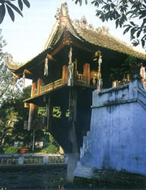

One-Pillar Pagoda is famous for its ancient architecture. It was originally called Dien Huu (Longevity) Pagoda. For many Vietnamese people, the image of the pagoda is the symbol of Viet Nam.
History says that the One-Pillar Dien Huu Pagoda was characterized as the symbol of Buddha. The Pagoda was built in 1049 by King Ly Thai Tong, who ruled from 1028 to 1054. According to the annals, one day, King Ly Thai Tong dreamed that he had met Quan The Am Bo Tat (Goddess of Mercy) taking him to a lotus flower. The King told his men the dream and he was told that it was the symbol of Longevity. The King immediately ordered the construction of the Pagoda in the shape of the lotus flower to worship Avalokitevara.
The pagoda was built in the Forbidden Citadel with a special architecture, all from wood. It was raised designedly on a single stone pillar to resemble a lotus blossom. It can stand firmly on top of the pillar because it is supported by a system of wooden rafters joined by tenons and mortises. The small pagoda in cubic-shaped covered with a curved roof. Each side is nine feet long with a curved roof placed on a round stone pillar. From the edge, there is a narrow brick path running through the pond to a nice ladder leading up into the Buddhist tower where there is a notice reading that the Lotus tower and pagoda were built in memory of a dream had by King Ly.

Hoan Kiem Lake & Ngoc Son Temple
Hoan Kiem Lake, or the Lake of the Restored Sword, is located directly in the centre of Hanoi. The name is derived from a legend involving Emperor Le Thai To, in which he came across a giant tortoise while cruising on the lake. The tortoise took his sword that had secured victory against the Chinese aggressors of the Minh Dynasty. The emperor named the lake after this episode
Every morning, the surrounding park fills with locals who arrive to exercise and play badminton. By the way, there still are a few tortoises who call this area home.
Hoan Kiem was already considered the most beautiful lake in Hanoi when Ngoc Son Temple was built on a small island during the 19th century. Saint Van Xuong, considered one of the brightest stars of Vietnam's literature and intellectual circles, was worshipped here. National hero Tran Hung Dao was also worshipped after he lad the Vietnamese people to victory over both Mongolian and Chinese invaders
Ngoc Ha Temple
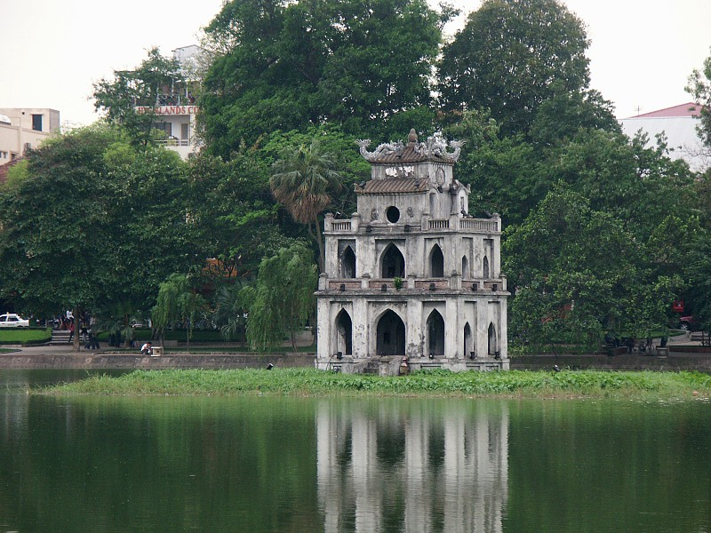
Ngoc Ha Temple was named after an old village, Ngoc Ha camp, one of 13 camps in the West of Thang Long (the old capital of Vietnam) formed in Ly Dynasty "Huyen Thien Hac De" deity is worshipped in this temple. Ngoc ha Temple was built to satisfy the customary religious need of worshipping a village deity and also a place for community meeting. Until now no documents concerning the temple's establishment have been found. However, the temple was built a long time ago and as the original structure was destroyed, the present is a replacement.
The date written on the temple shows that it was restored in the 10th Thanh Thai Year (1899). By investigating relics and records kept in the temple, it is estimated that the temple was built at the end of Le Dynasty and be repaired many times in Nguyen Dynasty. Today, we still can see its general architectural structure with ancient features such as gables, roof edges which were in the form of flying dragons and clouds. Many items of altar decoration of great artistic value are kept carefully in the temple. Besides being an architectural heritage, Ngoc Ha temple is also a historical site of anti-French activities in the late 19th century, even the August 1945 revolution and resistance war against the French from 1946 to 1954. Opening hours: morning to evening

West Lake (ho Tay)
West Lake is the biggest lake in central Hanoi, covering 500 ha in Tay Ho district. It is one of the main attractions of Hanoi City.
In the ancient times, this place used to be a famous resort reserved for kings and mandarins. Many beautiful palaces and monuments were built on the bank of the lake; among them are Thuy Hoa Palace, Tu Hoa Palace, Ham Nguyen Sanctuary, Kim Lien pagoda and Ngoc Dam Palace. The 14-km path around the lake leads to different places of interest such as Nghi Tam and Tay Ho flower villages, the peach gardens of Nhat Tan and the famous
Tay Ho Temple –
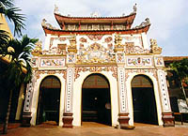

This pagoda is beautifully positioned on a peninsula projecting into West Lake. One of Hanoi's most popular on the first and 15th of each lunar month, it is dedicated to the Mother Goddess, Thanh Mau. According to legend, she appeared in the 17th century as a pretty girl before a fisherman on the lake, smiling and reciting poetry. Then she disappeared without revealing her identity. Later the locals found out who she really was and built the temple.
Situated on an island in the West Lake is the Tran Quoc pagoda, the oldest pagoda of Vietnam built in 541. Its ancient towers mirror in the lake water. Inside the pagoda there is a very precious statue, that of Buddha Sakyamuni entering Nirvana, a masterpiece of Vietnamese sculptural art.

Kim Lien Pagoda

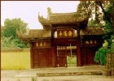

Kim Lien Pagoda was originally built on Nghi Tam peninsula, on the bank of West Lake. Princess Tu Hoa, daughter of Ly Than Tong King who reigned between 1128 and 1138, sent her royal representatives to this area to create the Tam Tang Center on Nghi Tam Street. The pagoda was later built in 1631.
Kim Lien is composed of three pavilions, each of which has 2 roof layers and the appearance of being slightly curved and supple. Apart from its nice disposition, the pagoda has a gate of sophisticated and intricate architecture.
Location: Today it is located in Quang An village, Tay Ho district, Hanoi. The pagoda was part of the former Tu Hoa Palace of the Ly dynasty.

Peach gardens of Nhat Tan and Flower village
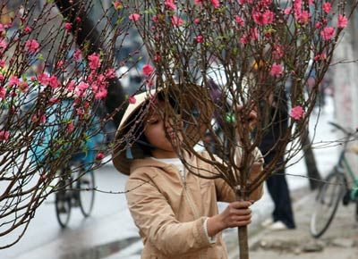
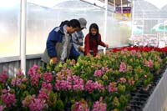

Peach blossoms are an enduring symbol of the Lunar New Year. Nguyen My Ha visits Nhat Tan where the delicate art of growing the trees is passed from generation to generation.
On the dirt road leading toward the Red River from Au Co Road, walk along a tall line of peach trees starting to bloom. Only a 10-minute drive from downtown Ha Noi, the scenery shows another world of chrysanthemums and daisies, lilies and marguerites. But the most majestic sight is the vivid hue of peach blossoms before Tet (Lunar New Year).
The flowers in Ha Noi’s traditional flower villages in the northern rim of West Lake, left over after the long building rush, are now budding. In Nhat Tan Village, people who want to avoid the rush have already come to pick out their favourite tree for Tet.
Army Museum
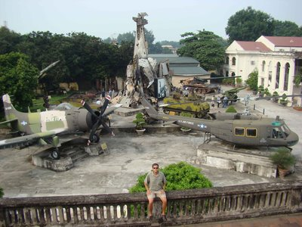
Don't miss the, which traces the country's military history from the 1930s to the present day. The exhibits are superb, ranging from captured tanks and aircraft to haunting photographs, espionage gear and guerrilla weaponry. As you might expect, the story of the war is told from the Vietnamese perspective, which can prove quite challenging for some visitors. For more on the War visit the Maison Centrale, otherwise known as the "Hanoi Hilton" where American POWs were held and interrogated.

HALONG BAY

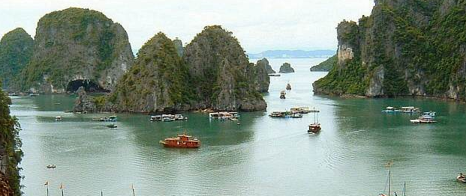

The concentration of karst limestone outcrops jutting out of the turquoise waters of Halong Bay is one of the most dramatic sights on the planet. According to local legend, the flailing tail of a dragon was responsible for forming the 3,000 jagged rocky islands extending for miles around the bay.
The best way to appreciate the splendour is to stay in Halong City and join a boat tour for a day, visiting caves and oddly-shaped islands. Boats leave from the city quays according to charter or schedule. Try to stay out late enough to see the sunset at sea.
Halong City itself has little to recommend it, and an alternative is to stay on Cat Ba Island. The beaches are good, and very popular with locals. An hour or so from the port there is an indigenous forest that makes for a good afternoon hike. The ferry to Cat Ba takes three hours from Haiphong Bay.

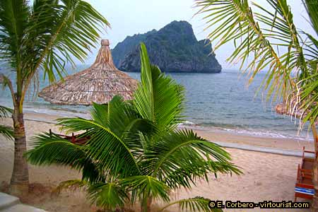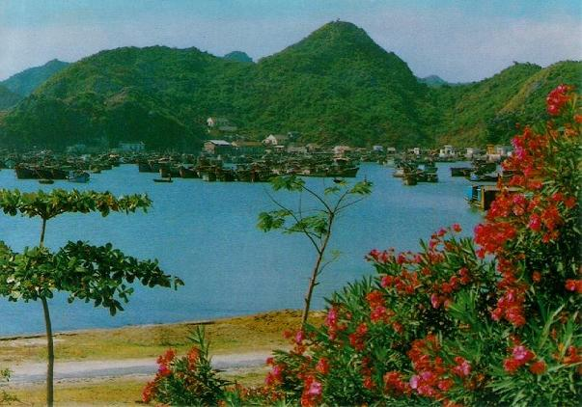
Cat Ba Island

The Thien Cung Cave
This is the most beautiful grotto full of stalactites and stalagmites. Tourists can have a good view of the calm bay surrounded by islets and abrupt coral reefs. The sparkling lights in the cave from the candle make it more magnificent.
The Dau Go Cave
This cave is great thanks to thousands of stalactites and stalagmites. It is naturally divided into 3 huge parts that can room 3,000 people at the same time. In the 13th century, one Tran dynasty general used to hide many wooden stakes used to wreck the Northern invaders’ warships.
The Trinh Nu Cave
There are many stalactites and stalagmites of queer shapes or young girls’ faces. A story was that a local mandarin kidnapped a nice girl of a poor fishing family as his concubine. She tried to escape but could not go home because her return might endanger her parents’ life. She decided to stay on this islet and committed suicide. Since then the cave was named the “Virgin Girl” cave.

Mekong Delta

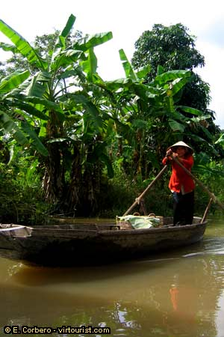
The stereotypical image of Vietnam is of a smiling farm worker wearing a cone-shaped hat and standing in a rice paddy, but in parts of the country this is a fair snapshot of rural life. On the Mekong Delta such scenes are commonplace.
Following its journey through the country, all the way through the country from Tibet, the mighty Mekong deposits enough nutrients in the Delta to make its name as the "rice-bowl" of the country no exaggeration. Gently undulating rice slopes stretch as far as the eye can see, an amazing agricultural scene. Local villagers work the fields by hand, back breaking work that they seem to undertake with amazing good-humour. Most are more than happy to be photographed in their work posture.
Despite being a photographer's paradise, the region is not overrun with tourists, enabling you to soak up the atmosphere in its full glory. Take a day trip from Ho Chi Minh City or go it alone by bus, cycle and boat.

Ca Mau
U Minh forest
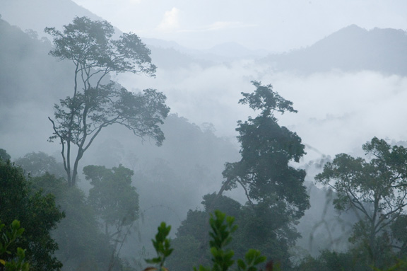
A large percentage of Ca Mau province's area is covered by forest; 150,000 ha being alluvial soils, typical of the tropical monsoon climate. Being flooded every day by tidal waters, the salt bearing trees grow in this environment with animals and micro organisms. The biological productivity of this land is highest among Vietnam's ecosystems.
Ngoc Hien Bird Sanctuary
Ngoc Hien is a final district of Ca Mau and is also the terminal area of Viet Nam. Ngoc Hien bird sanctuary belongs to Ngoc Hien district and covers an area of 130 ha. It is one of the biggest natural bird sanctuaries in Viet Nam. Ngoc Hien bird round is an ecological tourism spot and is also used to research the rare bird species that inhabit the area.
Hon Khoai
The Hon Khoai group of islands is 14.6 km from the main land, just southwest of the town of Nam Can. There five islands in extremely close proximity to one another: Hon Khoai, Hon Sao, Hon Doi Moi, Hon Da Le and Hon Tuong. They feature a total area of 400 ha and the highest reaches a peak of 318 m. From Ca Mau, tourists can also find the fishing village of Trande (at the southern end of the country's mainland) and ten continue on to Hon Khoai. The island was recognized by the Ministry of Culture and Information as a national vestige in 1994.
19th May Garden
The garden is in quarter No. 1, Ca Mau town and is the most attractive tourist spot in Ca Mau. The 18,2 hectare-large garden has a weekend entertainment area for the people of Ca Mau. There is a two-hectare-large natural bird sanctuary here that attracts many rare birds. Nowadays the 19th May garden is being invested in order to expand its area up to 6 hectares.

Cu Chi Tunnels

The ability of the Viet Cong to make themselves invisible was the most significant factor in the outcome of the "American War", and this was achieved by an intricate network of tunnels that allowed them to move where they wanted underground.
Many of these tunnels were originally only 80cm wide and high, but those at Cu Chi have been enlarged, ironically to accommodate larger Western girths. Visitors can climb into the tunnels and get an impression of what life was like for the people living here. Although claustrophobic, the sophisticated tunnel network incorporates dining areas, sleeping quarters and various booby traps to catch unsuspecting invading soldiers.
A few minutes in these cramped, dark spaces is enough for most people, which makes it all the more amazing that the Viet Cong spent weeks or months at a time below ground. Inadvertently the experience is rendered more authentic by the audible presence of a local shooting range. Located about 30km from Ho Chi Minh, the tourist tunnels are easily reached in a day trip from the city

Nha Trang

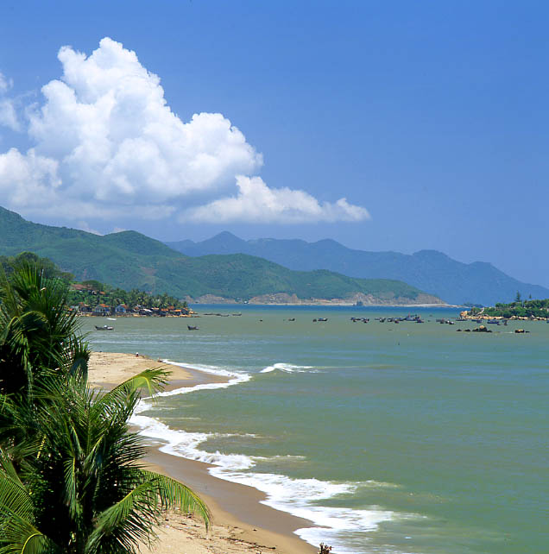

With over 3,000km of tropical coastline, Vietnam is a beach lover's paradise and nowhere is this more apparent than in the country's leading seaside resort of Nha Trang.
The palm-fringed beaches provide an ideal place to go swimming, get a massage or simply relax in the sun, with picturesque and relatively undiscovered offshore islands accessible by boat trips nearby. This is also one of the cheapest places in Asia to take a PADI certified learner diver course.
Tourism has hit Nha Trang in a fairly major way in recent years, so don't expect to find a haven of peace and quiet. Hawkers and other tourists fight for space on the beach in high season, making it a lively - rather than relaxed - getaway. The nearby ancient Cham ruins of the Po Nagar towers can be a place to get away from at least some of the hordes, and soak up some culture with your sun.
Beware of the unpleasant side effect of the increasing popularity of Nha Trang: security has become a concern on the beaches.
Nha Trang is the stunning capital of Khanh Hoa province. It is one of the nicest cities in southern Vietnam, blessed with lovely beaches, nineteen beautiful surrounding islands and great ice cream! Nha Trang is bound to be the first international resort town in Vietnam, and there are rumors that a Club Med is to be built here. Nha Trang already has large and expensive hotels built along the beachfront, intermingled with old French villas. Days on end can be spent aimlessly cycling the streets and the surroundings of Nha Trang. On days where it is too warm to cycle, take a boat trip out to the islands for a day of snorkeling in turquoise waters and coral reefs while savoring a fantastic seafood banquet for lunch, returning to town just in time towander down to the beach for a late afternoon beer of fruit shake.
Nha Trang is a large city, with a population over 200,000 and is predominantly flat, so the best way to get around is by bicycle. You can get a massage on the beach for about 3 US$ an hour. The beaches lining Tran Phu Boulevard are stunning and inviting, but unfortunately some foreigners ignore Vietnamese etiquette and culture by bathing topless or in very skimpy costumes. This is usually complimented by the obligatory group of young Vietnamese males looking on from distance.

Po Nagar Cham Tower
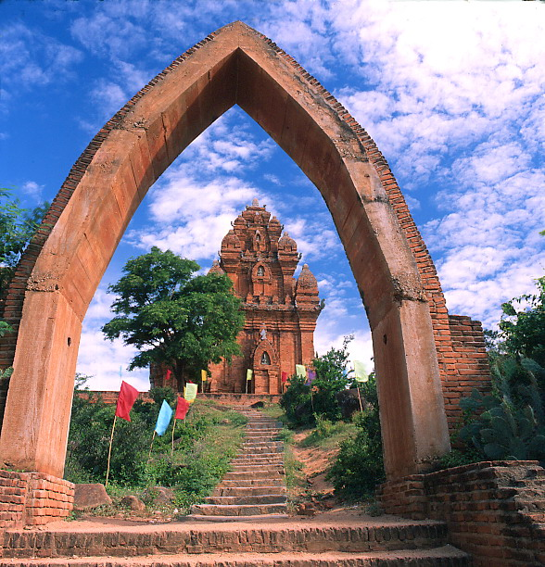

The Cham Towers are to the north of town and give you an insight into the culture of the ancient Cham people through the remnants of their brick temples dating from the 17 to 12 centuries. The north tower is 23 high and is dedicated to Po Nagar who was a mythical goddess. There used to be more towers, but they have been destroyed over time, and now there are only four functional towers left. There is a small interesting museum to the right of the north tower displaying photographs and ancient statues. Unfortunately most of the information is only in Vietnamese. The hillock upon which the Cham Towers sit offers a great panorama of the surrounds and a view over the entrance to the Cai river with Nha Trang as a background. There are a number of cafes within the grounds of the towers selling ridiculously priced food and drink.
The entrance to the site is at street level followed by a staircase op the hill to the towers. On you way up, on the right, you will notice the remains of the meditation hall, which was the original entrance for Cham worshippers. The other smaller towers are only meters away from this and all of them are militaristically facing due east. Make sure you take off your shoes before entering any of the temples here. The Cham Towers are on the north bank of the Cai River and are about a ten minute bike ride from the center of Nha Trang town. Follow Quang Trung Street from the center of town which turns into 2 thang 4 street. This will take you over Ha Ra bridge and then Xom Bong Bridge .
Hon Chong Promontory
the promontory just out into the South China Sea and offers a view of the bay and coast north of Nha Trang and nearby islands. There are a number of shops selling the same things including souvenirs, and some cafes with deck chairs set out to admire the view.
Giant Sitting Buddha and the Long Son Pagoda
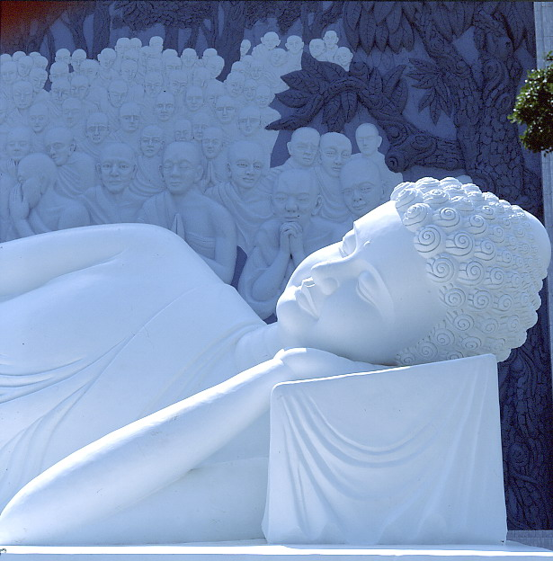

This enormous 9 m high Buddha was built quite recently in honor of those monks who elected self immolation rather than continue to live under the oppressive Diem regime. The white Buddha sits upon a hill close to the train station and is worthwhile going up for the view of Nha Trang and the coast. The large Buddha’s base used to be a library until it was closed after the Tet Offensive when it was discovered that the Viet Cong used the library to plan attacks on the city. The pagoda is at the base of the stairs that lead up to the giant Buddha and is very ornate with a strong Chinese influence

Dalat
Once known as the Paris of the East, Dalat is a hill town situated between Nha Trang and Ho Chi Minh City. At 1,500m the temperature is significantly cooler than it is on the humid coastal areas.
The town is frequently described as the most 'un-Vietnamese' town in Vietnam, mainly because it was built by French colonials seeking mountain retreat homes and even today a Gallic air remains. Relatively untouched during the Vietnam War, Dalat proved popular with Vietnam's revolutionary leaders, many of whom appropriated villas for their own use.
In the vicinity of Dalat are several outstanding waterfalls and the surrounding scenery is idyllic. Chief among Dalat's many highlights is the Crazy House, known more formally as the Hang Nga Guesthouse. This utterly unique and extravagant avant garde building is the work of a local artist who describes it as a "labour of love in process". Each of the guesthouse's rooms are decorated according to a different theme, each a triumph of kitsch and testament to a creative genius.
The Valley of Love is a resort area that is hugely popular with domestic honeymooners. The atmosphere is psychedelic Disney with staff dressed in outlandish costumes. The Lake of Sighs near the middle of the park epitomises the Vietnamese concept of romance.

Hoi An

The delightful river port of Hoi An is a UNESCO World Heritage site, and consequently a popular stop on tourist itineraries. It retains a distinctly "old world" feel in its streets, which are lined with an array of period buildings. A major international trading port from the 16th to 19th centuries, the fabulous blend of architectural styles includes a Japanese Covered Bridge, European style assembly halls and local merchants' houses.
Hoi An is additionally a tailoring centre of some renown. The main streets are lined with family run tailors, and prices are ridiculously cheap. Tailors copy designs from magazines, and can knock up a made-to-measure suit for you in 24 hours.
Once you've exhausted sightseeing and shopping opportunities, rent a bicycle and take a trip to the local beach. The ride there and back is exceptionally pleasant, as the road winds through rice paddies and past old churches being reclaimed by the jungle foliage.

Hue

Though much of this former capital of Vietnam was destroyed during the "American War", it retains a unique atmosphere of refinement that is hard to find in Hanoi or Ho Chi Minh City. There are some beautiful temples, palaces and pagodas that survived the war and which now form the backbone of the city's attractions.
Wander round the enormous 19th-century citadel surrounded by a moat and fortified gates, or explore the remains of the mysterious Imperial City. Equally rewarding is a stroll through the city's merchants' quarter whose winding streets still form the heart of Hue's commercial hub.
An essential part of any trip to the city is to take a boat ride along the Perfume River to see ancient pagodas and mausoleums. One of the most famous - and beautiful - structures here is the 17th-century Thien Mu Pagoda, its octagonal tower being a symbol for the whole city.
Hue is also well known for its excellent cuisine - don't leave town without trying banh khoai, a crispy pancake that is a local specialty.

The Citadel
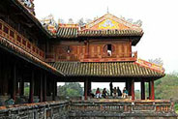
The Citadel consists of three cinctures, the moated Citadel (Kinh Thanh), the Imperial Enclosure (Hoang Thanh) and the Forbidden City (Cam Thanh). Constructed in 1805 by Emperor Gia Long, the big outer wall is 6 meters high, 11 kilometers long, with 11 gates and 24 watch-towers. This royal city is surrounded by some protective walls. Three sides of the Citadel are straight, the forth is rounded slightly to follow the curve of the river. The citadel suffered from big damages due to fire in 1945 and war bombardments.
The places of interest inside the Citadel are the flag tower, Ngo Mon Gate (The Noontime Gate), the Courtyard for royal ceremonies, the palace of supreme peace, halls of the mandarins, the memorial temple for Nguyen Kings, nine holy cannons, nine dynastic urns and the Forbidden City for the royal families.
King MinhMang’s Tomb
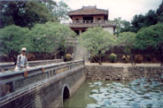
The construction was planed during the king’s lifetime and built between 1841 and 1843 by his successor. The palace, the pavilion, the entrances are harmoniously built around two big lakes that make these more luxurious and peaceful.
The three gates lead into the Honour Courtyard of the Tomb, Dai Hong Mon (Great Red Gate), Ta Hong Mon (Left Red Gate), Huu Hong Mon (Right Red Gate). From the Courtyard there are three granite staircases which are reached via the square Stele Pavilion, Dinh Vuong. The solemn emperor’s burial place is situated on a mound of earth covered with mature pine trees, behind Sung An Temple, some terraces and stone bridges.
King TuDuc’s Tomb
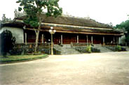
The King had designed himself this exquisite tomb and constructed it when he was still on the throne in 1848. The tomb was based on two axes, one for the mausoleum, and the other for the palace, 7 km far from the city, surrounded by a solid octagonal brick wall. It comprises an important number of buildings, temples, man-made ponds full of nenuphars and lotuses, crossed by various bridges and covered by frangipanis. This is one of the most romantic and splendid masterpieces. The king used this as the palace for working and relaxation when he was alive.
TuDuc’s sepulchre enclosed by wall is on a side of the Half Moon Lake. In fact, Tu Duc was never actually interred here. The place where he was buried has not been known yet. In order to keep the location secret, 200 servants who buried the King was all beheaded.
King KhaiDinh’s Tomb
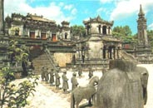
The ornate tomb of Khai Dinh, who ruled the country from 1916 to 1925, is perhaps a symptom of the decline of Vietnamese culture during the colonial period. Khai Dinh - the twelfth king of the Nguyen dynasty - is the father of King Bao Dai, the last emperor of Viet Nam.
The tomb's construction started in 1920 and completed in 1931. It is unlike Hue’s other tombs. The combination of Asian and European Architecture and decoration marks the king’s special interest in European civilization. The multi-colored ceramics inlaid style makes his mausoleum gracious and magnificent.
The Thien Mu Pagoda
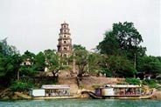
This Buddhist monastery was erected in 1601 by Lord Nguyen Hoang, the ancestor of the Nguyen dynasty. It was renovated in 1844 under King ThieuTri’s sovereignty. Legends said that one night people found an old lady sitting on this small hill, wearing a red long dress and green trousers and she claimed that this place belonged to the supernatural power, so a pagoda should be constructed here. After saying that, the lady disappeared in the cloud. Since then it was called the pagoda of the old celestial goddess.

Ho Chi Minh Mausoleum
Though it may sound a bit morbid to pay a visit to a tomb, the experience is essential to help understand the importance of "Uncle Ho" in building the nation. The mausoleum in Hanoi has become a pilgrimage site for people from all over the country.
Crowds of solemn Vietnamese walk slowly past the glass coffin where the wispy beard and shiny forehead of the country's liberator are frozen in time. The older visitors often include former Viet Cong guerillas that fought under the leadership of Ho Chi Minh against the French colonial army when independence was declared in 1945.
To avoid disappointment take careful note of the somewhat erratic opening hours, and last entry times. Also, you must dress appropriately and demonstrate respect while visiting. The nearby Ho Chi Minh Museum and the leader's former house provide further insights into the life and times of Vietnam's key national hero.

Sapa
A trip from Hanoi into the Tonkinese Alps at Sapa is rewarded with wonderful views of Fansipan, at 3,143m the country's highest mountain.
A French colonial hill station in the 1920s, Sapa is home to numerous minority groups such as the Red Zao, Black Hmong and Lantien Yao people. These peoples' colourful traditional costumes lend a vibrant air to the town, particularly during the weekend market. In the environs, enticing trails lead off to neighbouring villages or - for the more serious climbers - up Mt Fansipan.
A trip here still represents something of an adventure, although scheduled tours are becoming more common. Due to its altitude, the region offers a welcome respite from the humidity of the rest of the country, but don't get caught out - it can get too cold for comfort as well.

Cham Towers
Dotted around the countryside of Central Vietnam are several crumbling towers built by the Chams, one of the country's ethnic minority groups.
These atmospheric temples are impressive relics of the once great Cham civilization, which flourished in the 14th century, and, through feuds with neighbours, was largely responsible for the downfall of Angkor Wat in Cambodia. The influence of Hinduism is obvious in the figures carved on the towers, though the majority of Chams today are Muslims.
The best places to see Cham Towers are My Son and Phan Rang, two of the largest complexes of towers located in picturesque rural settings.

DA NANG
990 km far from Ho Chi Minh City, Da Nang is the coastal town lying by a river, surrounded by several mountains, with a busy port and splendid beaches such as Non Nuoc Beach (known as China Beach), and Tien Sa Beach. It is here in the 17th and the 19th centuries the Spanish and the French disembarked to attack the Vietnamese. The American jumped into Da Nang and built the biggest air base in the South-East of Asia. The city has been controlled by the Liberation Front after March 1975. Nowadays, Da Nang remains an active port and develops remarkably thanks to the open policy. Its city offers good beaches and nice resorts for any tourists.
The Cham Museum
The Cham museum is the one which has the largest collection of Cham sculptures in the country. More than 300 fascinating sculptural statues and bas-reliefs have been collected from different sites of Cham kingdom like Tra Kieu, Dong Duong, My Son and preserved in the special museum built by the French. The ancient objects for display dated from the 4th to 12th century. It is really a big attraction for every tourist.
The Marble Mountain
This Marble Mountain is also called the site of 5 elements: gold, wood, water, fire, earth. Legends said these 5 mounts used to be the egg shells left by a dragon. There are many caves with historic Buddhist temples for pilgrims. At the foot of the mountain stone-making workers are busy making sculptures and marble bas-reliefs and thousand souvenirs from stone.

Non Nuoc Beach
Non Nuoc is near the Marble Mountain, next to an area called China Beach famous for a series of American Tivi reels. It is one of the most beautiful and longest beaches with white sand frequented by foreign tourists and local people. Many interesting fishing boats, street cafes, and refreshment bars are popular around.

Ho Chi Minh City
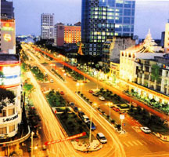
After 1975, the government of Ha Noi renamed Sai Gon to Ho Chi Minh City. But the people never quite gotten accustomed to the new name and thus still prefer the old name, Sai Gon. In official publications, however, only Ho Chi Minh City is used.
With a population of over seven million, Sai Gon is the economic center of Viet Nam. It is also a commercial trading hub between China, Taiwan, Japan, Thailand, Malaysia, and other foreign countries. The city is bustling, with colorful free-markets and activities. The city was filled with the incessant rattling of cars, motobikes, and tri-cycles. However, this free-spirited city with tree shaded streets, old colonial architecture and gentle charms, still retains its small warm town feel. Sai Gon is also very active at night with music halls open and restaurants stay open all night long.Sai Gon with its street markets, sidewalk cafes, sleek new pubs, pagodas and museums it is impossible to get bored in Ho Chi Minh City.
The Historical Museum
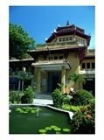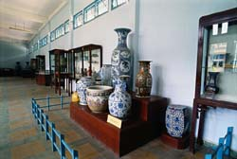
Is a huge collection of historical objects relating to the development of Viet Nam history? Situated within the famous botanical garden aged more than 100 years, it keeps the most information and objects of some civilizations in the Mekong Delta such as Oc Eo (Funan)… Botanical gardens and zoo open daily. Researchers can get special permits to stay inside its great library for study. Live water puppet shows can be enjoyed in here.
War Museum
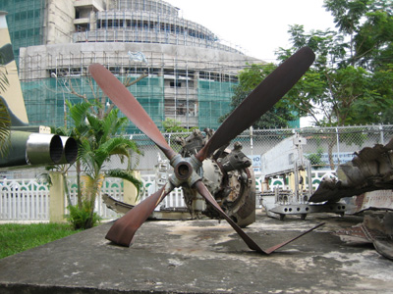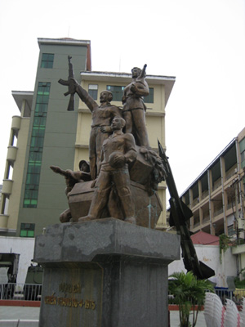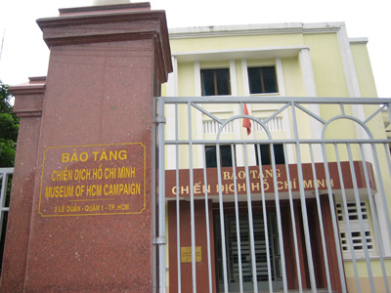
Wreckage from the Vietnam War Main Entrance of the Museum

That is a big collection of weapons and information on the modern wars in Viet Nam. It presents the war crimes caused to the Vietnamese people. Visitors can see the model of the most terrible prison and the most lethal weapons used by foreign armies in Viet Nam. A notorious guillotine is also on display. Location: 2 Le Duan, District 1, Ho Chi Minh City, Vietnam

Notre Dame Cathedral
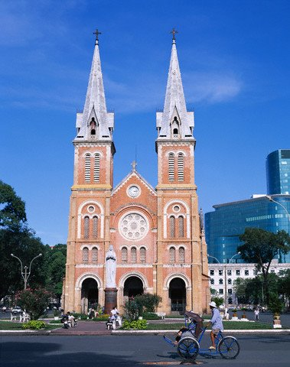
The church was built during 1877 and 1883 by the French, who imported all materials from France- Notre Dame with Virgin Maria for many Catholic followers, so that their power in this colonial was shown. The church today is one of the Catholic centers of the country. Sai Gon Archbishop is working there. Some Vietnamese Catholic saints are also worshipped there. Two services in the morning and in the afternoon are convenient for all believers. The most crowded time for the church is New Year time and Christmas...
China Town - Cho Lon
Cho Lon or China town over here is a bustling town for more than 5 million Chinese inhabitants. China town was set up by the end of 18th century when the Minh dynasty in China was overthrown. Many Chinese faithful to the Minh ran to Viet Nam for help, peace and business and were permitted by the Nguyen Lords. China town has many shops and family factories. The most interesting place is Binh Tay market built by one Chinese businessman, always crowded as a wholesale market. Walking into the Soai Kinh Lam material market is very interesting. Father Tam’s Catholic Church for Chinese is historical as the first president of the south Ngo Dinh Diem and his brother hid themselves to avoid the coup-detat in 1963. China town never sleeps with all interesting activities. Most merchandize can be purchased at wholesale price in China town.
Thien Hau Temple
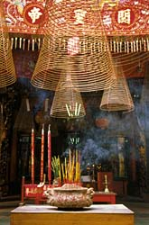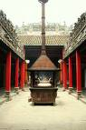
Considered as one of the most ancient Chinese temple, the place is consecrated to the Sea goddess bas on Chinese folk beliefs. The temple is a place for other gods such as Money God, Mother Goddess, and Mermaid…Queer and ancient worshipping things are precious and worth seeing. A prayer for good health and business can be said after an incense coil is purchased. Good luck in doing business can be granted by the Money God after some money is offered to him.
Giac Lam Pagoda
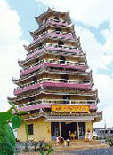
Giac Lam pagoda, the oldest Buddhist pagoda in Sai Gon, was built in 1744 from a fund drive by Ly Thuy Long, a native of Minh Huong village, who then transferred it to Ch’an Master Phat Y. Inside this pagoda is a huge collection of old Buddha and Arhat’s statues. Ancient furnishings and statue arrangements will keep tourists interested. Things for decoration dated back some hundred years ago. It is an active temple. Prayers consist of chanting to the accompaniment of drums, bells and gongs and follow a traditional rite seldom performed these days.
Because the last reconstruction was in 1900, the architecture, layout and ornamentation have remained almost unaltered - unlike most other pagodas in this city.

Indian Restaurants:

Alibaba
Address: 60, Le Thahn Ton, Dist 1, Ho Chi Minh City Vietnam
Tel: 84-8 8233594

Ashoka
Address: 17-10, Le Thanh Ton St, Dist 1, Ho Chi Minh City Vietnam
Tel:84-8-8231372

Bombay Indian Restaurant
Address: 34, Hung Vuong St, Nha Trang, Vietnam
Tel:058-816206

Bombay Indian Restaurant
Address:15, Biet Thu St, Nha Trang, Vietnam
Tel: 058-312557

Dakshin
Address: 194, Hang Trong, Hanoi Vietnam
Tel:84-4-9286872

Delhi Restaurant
Tel:41, Hai Ba Trung St, Dist. 1, Ho Chi Minh City Vietnam
Tel: 84-8-8222284

Indian Heritage
Address: 12 Thai Van Lung, Ho Chi Minh City Vietnam
Tel: 84-8 8234687

Khazana
Address:41B, Ly Thai To St, Hanoi, Vietnam
Tel: 04-8241166

Omar's Indian Restaurant
Address: 96A/8 Tran Phu St Nha Trang, Vietnam
Tel: 058-814489

Omar's Indian Restaurant
Address: 14, Phan Dinh Phung St, Hoi An, Vietnam
Tel: 0510-864538

Omar's Indian Restaurant
Address: 10, Nguyen Tri Phuong St, Hue, Vietnam
Tel: 054-821616

Revival
Address: 41B, Ly Thai To, Hanoi Vietnam
Tel: 84-4-8241166

Saigon Indian Restaurant
Address: 73, 1st Fl, Mac Thi Buoi, Dist 1, Ho Chi Minh City Vietnam
Tel: 84-8-8245671

Taj Mahal Indian Restaurant
Address: 26, Bui Vien Q1, Ho Chi Minh City, Vietnam
Tel: 058-8639363

Tandoor
Address: 24, Hang Be St, Hanoi, Vietnam
Tel: 84-4-8242252

Tandoor
Address: 103, Vo Van Tan, Dist 3, Ho Chi Minh City, Vietnam
Tel: 84-8-8244839

Urvashi
Address:27, Hai Trieu St, Dist. 1, Ho Chi Minh City, Vietnam
Tel: 84-8-8213102

